  Apr 13 - 6:30pm Town Library, upstairs  Meeting Theme: Spring Fever  Wear: blue for the rainy season | Business Topics: Welcome current and new members! Dues, 2026 plans, town common clean up  Gardening Chatter: What’s your “can’t fail” early grower? What’s your first garden task of spring?  Optional Activity: Seed swap, bring seeds and or seedlings to share (seedlings must be in new, clean pots with new clean potting soil)
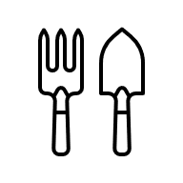
Volunteers Needed (Early May, Date TBD): Join your fellow members to help clean up the town gardens
May 11 - Note early start time: 6pm, Town Library, upstairs  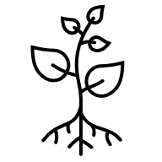  Meeting Theme: Herb Your Enthusiasm  Wear: a bright floral | 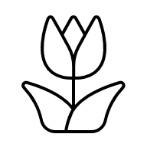  GUEST SPEAKER(s): Scholarship Winner (if applicable) and Climate Resilient Gardening with UNH Extension  Gardening Chatter: What herbs are you growing this year? What are your  favorite go to container annuals?
Jun 8 - 6:30pm Town Library, upstairs    Meeting Theme: Bee our Guest  Wear: yellow or black | GUEST SPEAKER: Tods, Vixens, Pups & Kits: Fun Facts about the Fabulous Fox with Willa Coroka  Business Topics: Upcoming events preparation for Old Home Day, Mum Sale  Gardening Chatter: Which plants in your yard are currently attracting the most pollinators? What’s your favorite spring scent in the garden?

Our July meeting is TBD for date and location – we will share details once confirmed
Aug 10 - 6:30pm Town Library, upstairs  Meeting Theme: Weed It and Reap  Wear: whatever you wear to beat the heat | Business Topics: Mum sale prep and volunteers, OHD volunteers  Gardening Chatter: What’s your most persistent weed? Favorite weeding tools or hacks?  Activity: “Grandma’s Garden Secrets”, share old-time or handed-down tips

Save the date: August 15, Old Home Day Parade, call for volunteers to walk in the parade
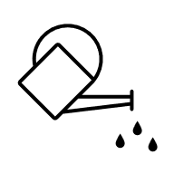
Save the date: September 10-13, Fall Mum Sale, call for volunteers to support all aspects of the sale
Sept 14 - 6:30pm Town Library, upstairs  Meeting Theme: Harvest Hysteria  Wear: anything green or something with a vegetable on it | Business Topics: Mum Sale  Gardening Chatter: Biggest or strangest vegetable of the season? What do you preserve or share?  Activity: Share your biggest gardening lesson from the season, what was your best garden performer in 2026?
Oct 12 - 6:30pm Town Library, upstairs  Meeting Theme: A Ghoul in the Garden  Wear: think spooky or Halloween themed |   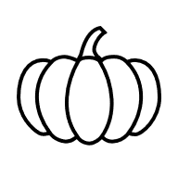  Gardening Chatter: Do you clean up or “leave the leaves”?  Which plants look best in decay?  Activity: House Plant Swap!

Volunteers Needed (October, Date TBD): Join your fellow members to help clean up the town gardens
Save the date: October 31, Trick or Treating on the Town Common
Interested in coordinating candy or decorating? We know you want to be a witch this year! Email Dunbartonrec@gmail.com to get involved.
Nov 9 - 6:30pm Town Library, upstairs  Meeting Theme: Garden Gratitude  Wear: a harvest color | GUEST SPEAKER: Winter Seed Sowing of Native Perennials for Your Garden with UNH Extension    Gardening Chatter: What garden moment brought you joy this year?  Any new plants or approaches you’ll try? One thing you’d never do again?
  Dec 14 - 6:30pm Town Library, upstairs  Meeting Theme: Deck the Halls  Wear: anything festive | Celebrate the holiday season with your fellow members!  Gardening Chatter: What natural materials do you use for winter décor?  Favorite wreath-making or centerpiece trick?

